Pre-Calculus Honors Worksheet 3.1-3.2 Name:______________________________

Use what you have learned about transformations and how they manifest themselves in a function’s notation to graph the functions that follow. Information pertaining to the mother graphs of each curve is provided.

Exponential Functions Logarithmic Functions
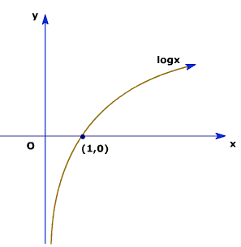
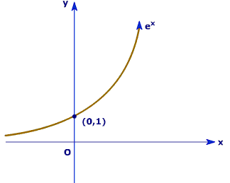

$f\left(x\right)=b^{x}$ $f\left(x\right)=\log_{b}{x}$
Domain: $\left(-∞,∞\right)$ Domain: $\left(0,∞\right)$
Range: $\left(0,∞\right)$ Range: $\left(-∞,∞\right)$
Key Point: (0,1) Key Point: (1,0)
Horizontal Asymptote: y = 0 Vertical Asymptote: x = 0
The “math idea” is the exponent. The “math idea” is the logarithm.

*A vertical shift occurs when a number is added/subtracted outside of the “math idea”.
*A horizontal shift occurs when a number is added/subtracted inside of the “math idea”.
*An x-axis reflection occurs when the “math idea” is made negative.
*A y-axis reflection occurs when the x inside the math idea is made negative.
*A vertical stretch occurs when a number, a, is multiplied to the “math idea”. If a > 1, it will make the
y-values grow faster/narrow the curve. If 0 <a < 1, it will make the y-values grow slower/widen the
curve.

We will discuss tomorrow what the different values of the base in both the exponential curve
and the logarithmic curve does to the sketch. For now, assume it does nothing.

Sketch the graph of the following functions. Be sure to indicate the domain, range, location of the key point and the location of the asymptote.

1. $f\left(x\right)=3^{x}+1$ 2. $f\left(x\right)=log\left(x-1\right)$ 3. $f\left(x\right)=2^{x+1}$

4. $f\left(x\right)=1-log{x}$ 5. $f\left(x\right)=e^{x}$ 6. ${f\left(x\right)=5+log}_{3}{(3-x)}$

7. $f\left(x\right)=lnx$ 8. $f\left(x\right)=3^{2-x}-4$ 9. $f\left(x\right)={-5}^{x}$

