Pre-Calculus Honors Behavior & Graphs of Polynomial Functions Section 2.3

Write the polynomial in standard form, state the leading coefficient, state the degree and describe the end behavior using

1. 

2. 

3. 

4. 

5. 

State the maximum number of turns and the possible number of positive and negative, real roots for each polynomial.

6. 

7. 

8. 

For each polynomial, state the degree, the number of real zeros and the number of complex zeros.

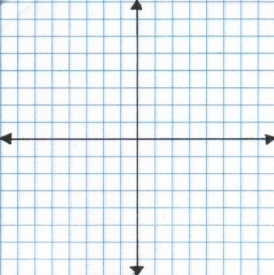

9. 10.

Write the equation of the polynomial with the given characteristics. Remember that unless a specific point is indicated, the equation should be generic.

11. 12.

For each polynomial function, find the x- and y-intercepts, state the multiplicity of each x-intercept, determine whether the graph crosses or touches the x-axis at each x-intercept, state the maximum number of turns of the graph, and using a graphing calculator, state all local extrema, if any exist, to the ten-thousandth place.

13. $f\left(x\right)={(x-1)}^{2}$

14. $f\left(x\right)=6x^{3}(x+4)$

15. $f\left(x\right)=x(x-2)(x+4)$

16. $f\left(x\right)=x^{2}(x-2)(x+2)$