Unit 2 Polynomials and Rational Functions

Review of Terminology
polynomial: any function whose variables are to positive, whole # exponents

terms: the pieces of the polynomial that are sep. by + or –

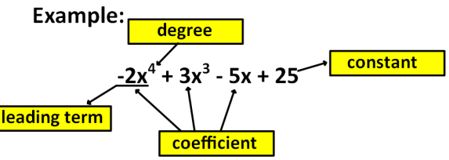
like terms: terms with same power and same variable(s)

binomial: two termed poly; contains one sign

trinomial: three termed poly; contains 2 signs

degree: the highest exponent on a variable

leading coefficient: the coefficient of the term with the highest exponent; take their sign

Zeros of a Polynomial: the location where the graph crosses the x-axis; synonyms: x-intercepts, roots, solutions

Standard form of a Polynomial: polynomial written from highest exponent to lowest exponent

Types of Polynomials by Degree
*linear: degree 1
*quadratic: degree 2
*cubic: degree 3
*quartic: degree 4

*The degree (n) of the polynomial gives a hint as to shape of the curve.
*number of zeros = n
*the maximum number of local extrema = (n-1)

End Behavior
~odd degree ends opposite directions
~even degree ends in same direction

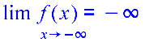
1. pos LC and odd degree:
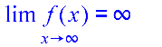
2. neg LC and odd degree:

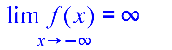
3. pos LC and even degree:

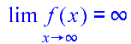
4. neg LC and even degree:

Complex Zeros: total number of zeros including both real and imaginary zeros

Imaginary Zeros: won't show on a graph; always show up as conjugate pairs: $a+bi and a-bi$

Descartes Rule of Signs helps determine the possible number of real zeros

~possible number of positive, real zeros: put the function in standard form, then count the number of sign changes from one term
to the next. List that value and subtract two until you reach 1 or 0
~possible numbe of negative, real zeros: put the function in standard form, then change the sign of the odd degreed terms and
count the number of sign changes from one term to the next. List that value and subtract
two until you reach 1 or 0
Graphs of Higher Powers

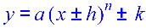
*if in the form then we transform them just like we do all other graphs that we've learned. If n is odd, graph like a cubic. If n is even, graph like a quadratic.
*if not in that form, then use a calculator!
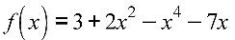
Ex For state the following:

A. Standard Form: B. Degree: C. Leading Coefficient: D. Type of Polynomial by Degree:

E. End Behavior using Limit Notation: F. Number of Roots/Number of Complex Zeros:

G. Maximum Number of Relative Extrema: H. Possible Number of Positive, Real Roots:

I. Possible Number of Negative, Real Roots: J. Number of Imaginary Zeros:
Finding Zeros of a Polynomial
*to find the zeros of a polynomial, set the function = 0 and solve.
*The following techniques may be used for solving:
~factoring
~quadratic formula
~long division
~synthetic division (rational root theorem)
~use of the graphing calculator

I. Factoring and/or Quadratic Formula
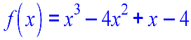
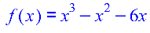
Ex Find the zeros: Ex State the roots of

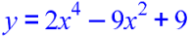
Ex Find the solutions of

~If a polynomial is in factored form already, just set the factors equal to zero and solve.
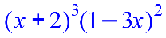
Ex State the zeros of

Multiplicity
*When in factored form, the outer exponent represents the number of roots that factor represents. Factors with an outer
exponent greater than 1 are said to have multiplicity.
*Multiplicity tells us something about the graph of the polynomial.
~if the multiplicity is odd, the graph will transition THROUGH the root to the other side of the x-axis.
~If the multiplicity is even, the graph will TOUCH/KISS the x-axis and return to the same side of the x-axis from where it came.

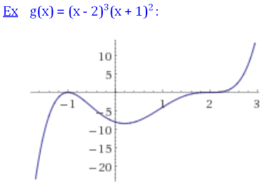

Intermediate Value Theorem --> a sign change in the range implies a real zero exists somewhere between the two values of the range.
