**Pre-Calculus Honors Notes Review of Lines**

*Intercepts*

* x-intercept: where the graph touches the x-axis
  + - the x-value when 
    - Written as an ordered pair 
    - When given an equation and asked to find the x-intercept, substitute zero in for all y-values and solve for x. (ignore the y portion of the equation)
    - also called a “zero” or a “root”
* y-intercept: where the graph touches the y-axis
  + - the y-value when 
    - the initial value
    - Written as an ordered pair 
    - When given an equation and asked to find the y-intercept, substitute zero

In for all x-values and solve for y. (ignore the x portion of the equation)

Examples: Find the x- and y-intercepts. Be sure to write as an ordered pair.

A.  B. 

*Graphing*

* We will use two methods for graphing---by intercepts and using slope-intercept form.
* 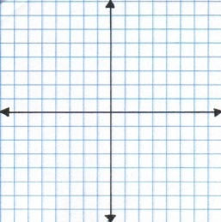Intercepts: Best for lines given in standard form. Find the x- and y-intercept. Plot the points and connect.
* Example: Graph  using intercepts.
* Slope-Intercept Form: Best for lines given in form where *m* is the slope and *b* represents the y-intercept, . Plot the y-intercept on the y-axis and move from the point using the slope value.
* Example: Graph  using slope-intercept form.

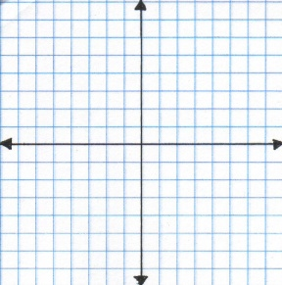

*Lines, Slopes & Graphs*

* Decreasing Lines:  Increasing Lines: 

negative slope positive slope

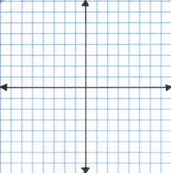

* Horizontal Lines:  Vertical Lines: 

zero slope undefined slope



* Parallel lines have the same slope.
  + Example: State the slope of a line parallel to the given line.

A.  B. 

* Perpendicular lines have negative, reciprocal slopes.
  + Example: State the slope of a line perpendicular to the given line.

A.  B. 

*To write the equation of a line you must have two things: a slope & a point

* *slope rise over run; the change in y over the change in x 
* can be referred to as the “average rate of change” or “rate of change”

*There are three forms in which the equation of a line can be written:

*Point Slope Form*:  In this form numbers may only be inserted for

. This is the initial form to be able to get

to the other two forms.

*Slope-Intercept Form:*   *m* is the slope and *b* represents the

y-intercept, .

*Standard Form:*  , A must be a positive, whole number

Examples: Write an equation of a line represented by the given information in all three forms.

A. a line with  passing through  B. a line passing through  and 

C. an undefined slope passing through  D. a slope of zero passing through 

E. a vertical line passing through  F. an horizontal line passing through 

G. x-intercept at 5 and y-intercept at -3

H. a line parallel to  passing through 

I. a line perpendicular to  passing through 