Pre-Calculus Honors Name:______________________________

Worksheet 1.2 Date:_________________ Period:______

Given the graph of ,answer the questions that follow.

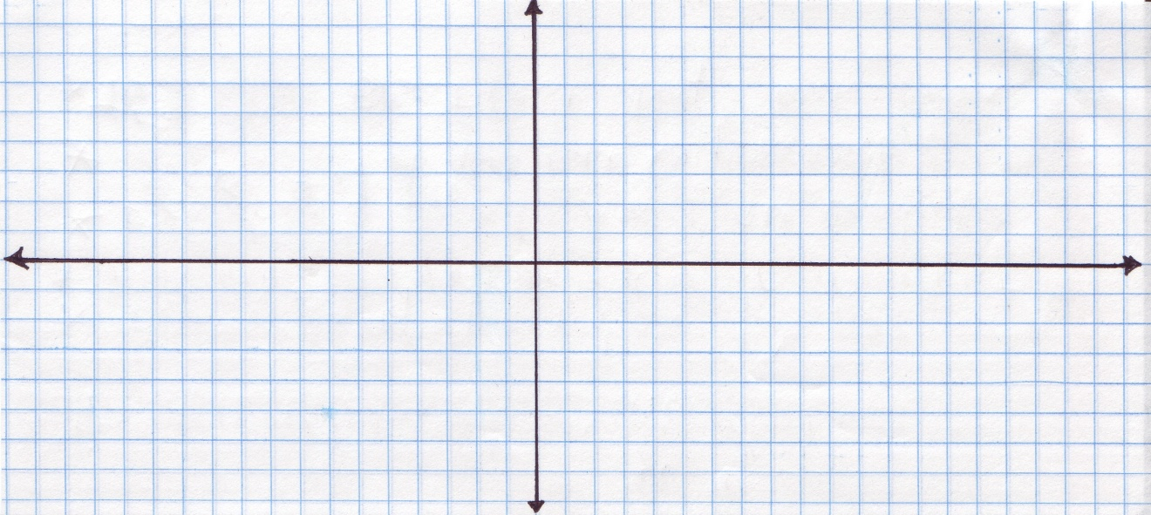

|  |  |
| --- | --- |
| 1. State the interval(s) on which *f(x)* is increasing. | |
| 2. State the interval(s) on which *f(x)* is decreasing. | |
| 3. State the interval(s) on which *f(x)* is constant. | |
| 4. State the domain in interval notation. | |
| 5. State the range in interval notation. | |
| 6. State any relative minima. (ordered pair) | |
| 7. State any relative maxima. (ordered pair) | |
| 8. State the absolute maximum, if possible. | 9. State the absolute minimum, if possible. |
| 10. Is it continuous? If not, state the type of discontinuity and the x-coordinate at which the  discontinuity occurs. | |
| 11. Is it bounded? If so explain how it is bounded. | |
| 12. Find $f(-1)$. | |